**Studio 9**

**Design to Code Traceability**

Jay Patel

Christian Klein

Joseph Thill

Derek Yu

Zifeng Jiang

**Modified Class Diagram**

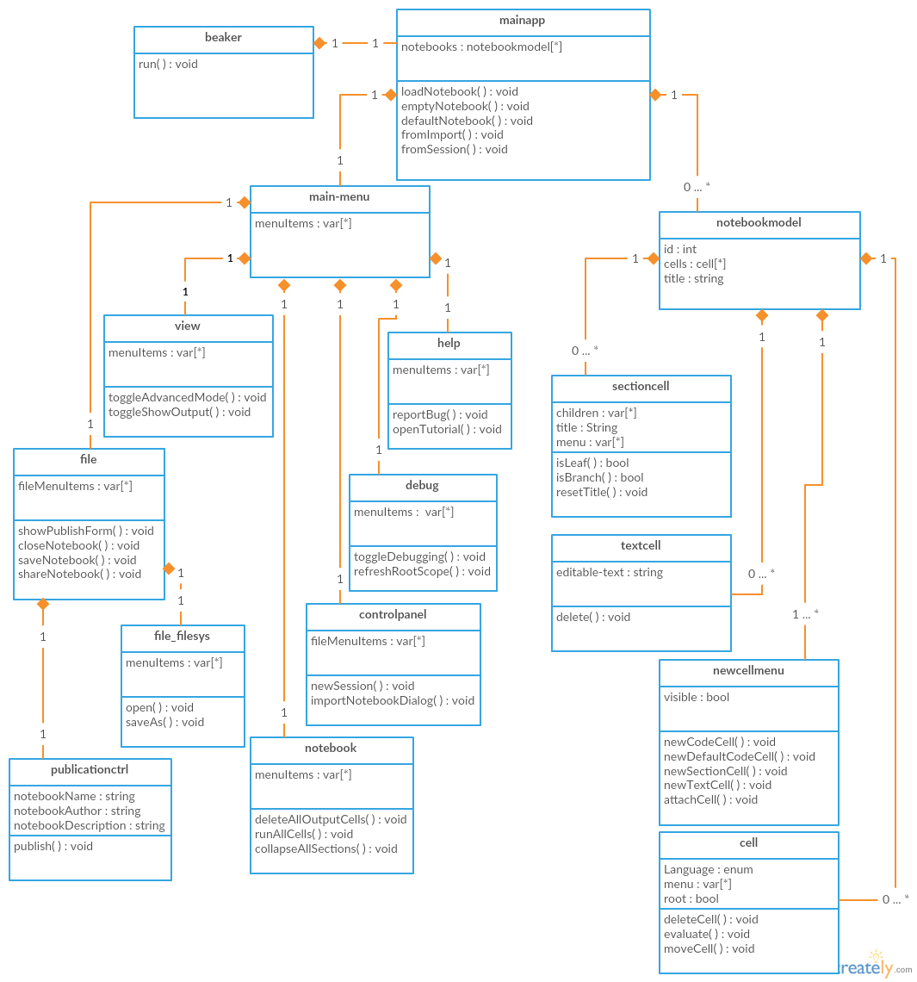

**Modified Communication Diagrams**

**Use Case 1 - New Previous Cell**

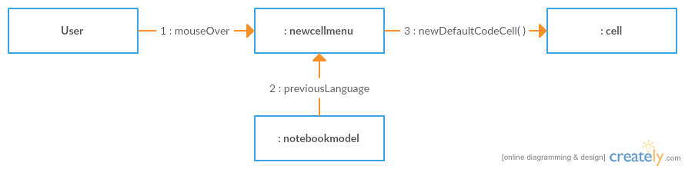

**Use Case 2 - Create New Empty Workbook**

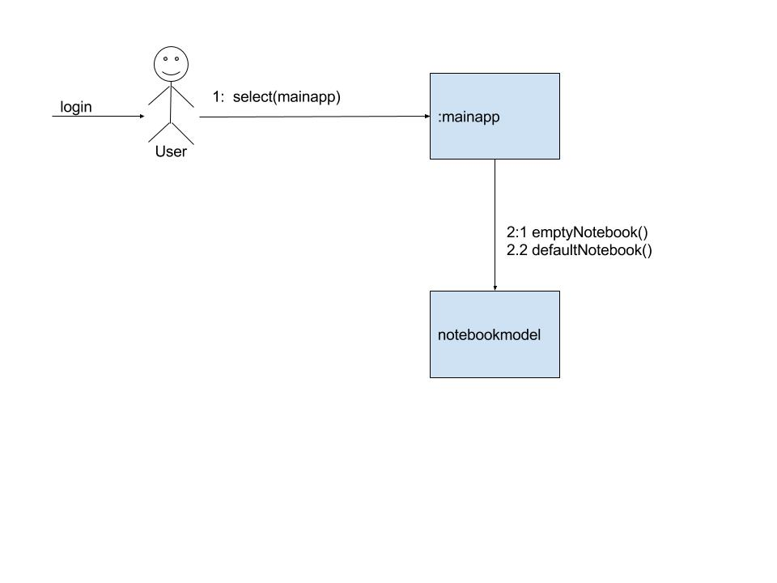

**Use Case 3 - Report Bug**

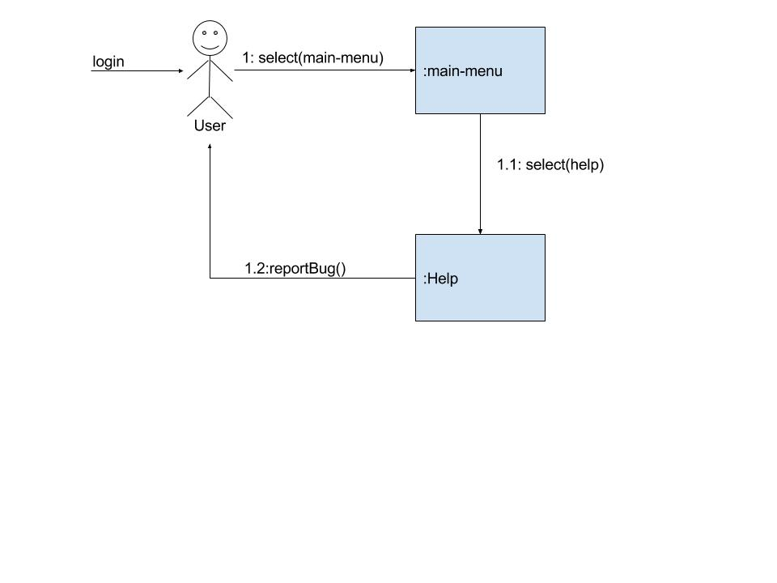

**Use Case 4 - Switch to Advanced View**

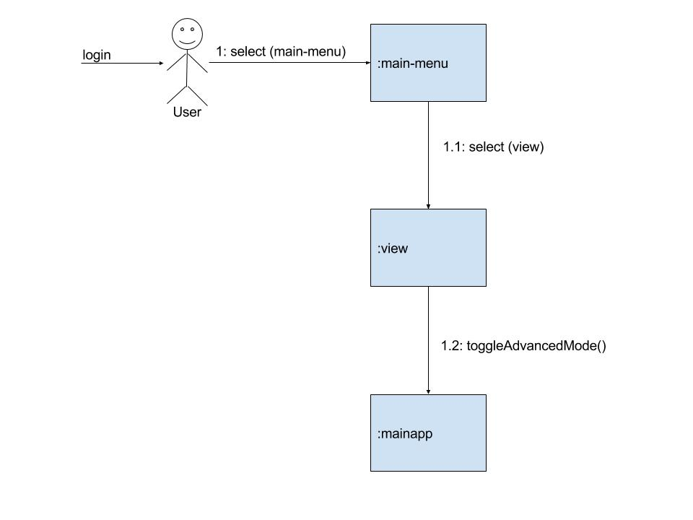

**Use Case 5 - New Cell**

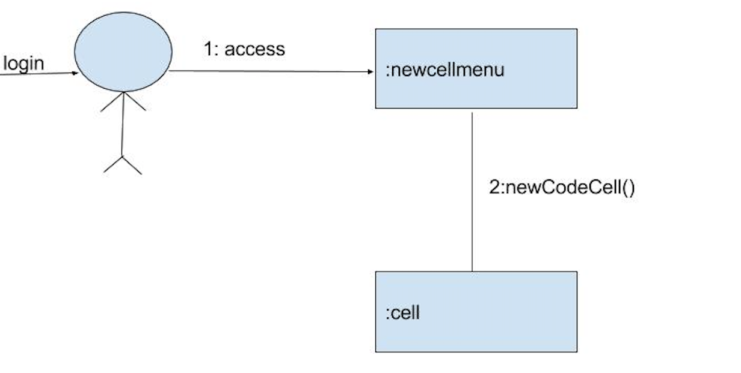

**Use Case 6 - New Textbox**

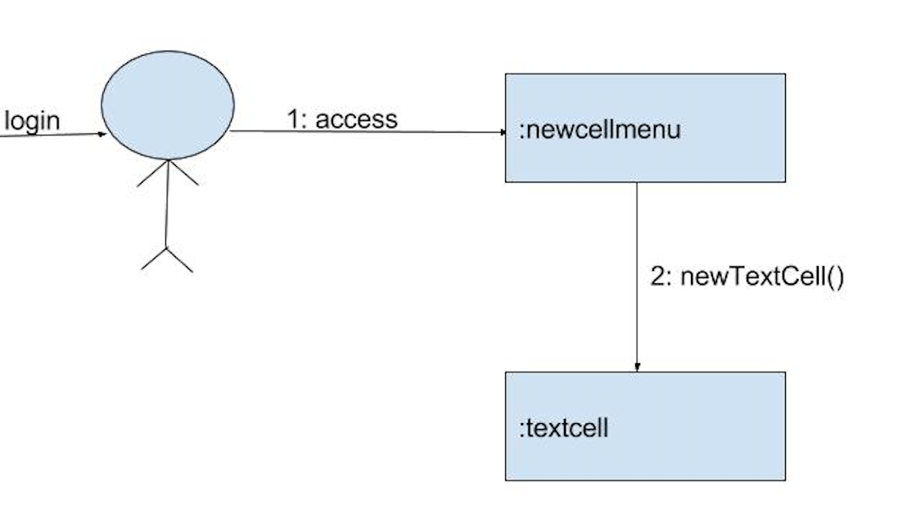

**Use Case 7 - Run Cell**

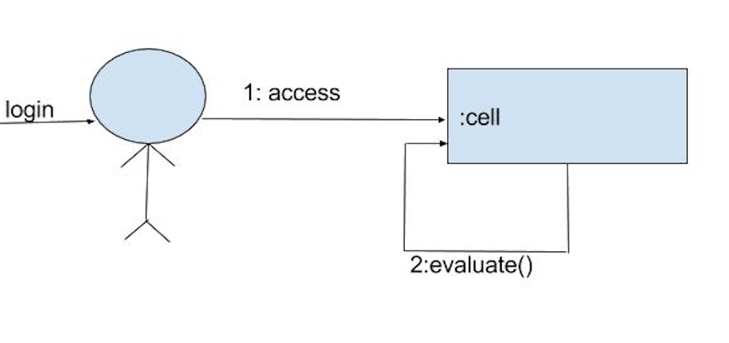

**Use Case 8 - Open Javascript Tutorial**

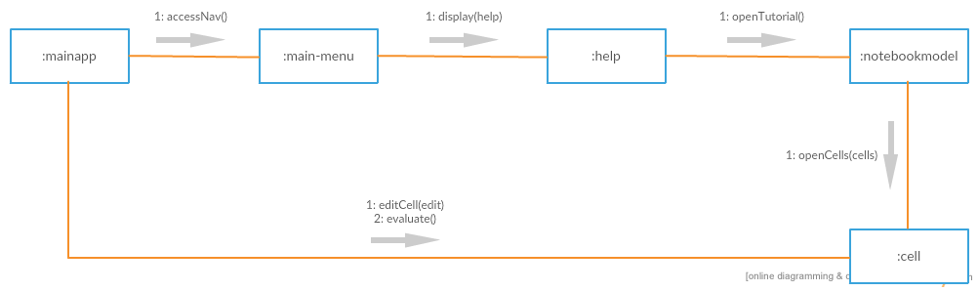

**Use Case 9 - Upload File**

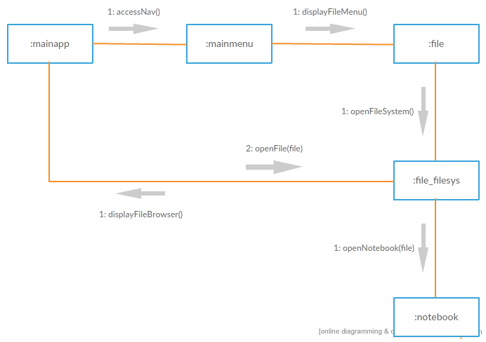

**Use Case 10 - Publish**

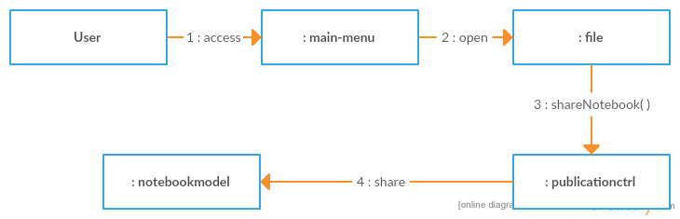

**Use Case 11 - Delete Cell**

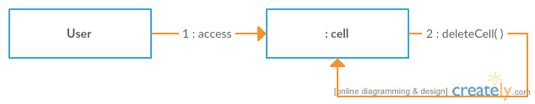

**Use Case 12 - Save Notebook**

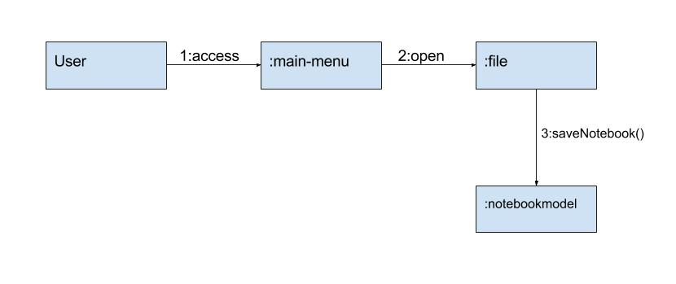

**Use Case 13 - Create Sections**

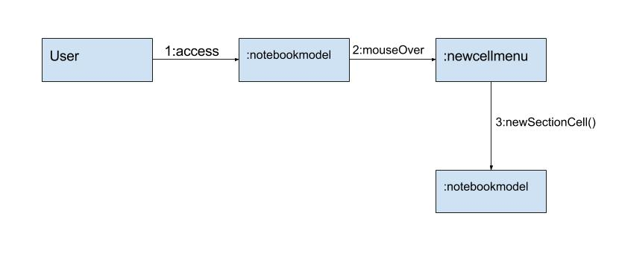

**Use Case 14 - Run All Cells**

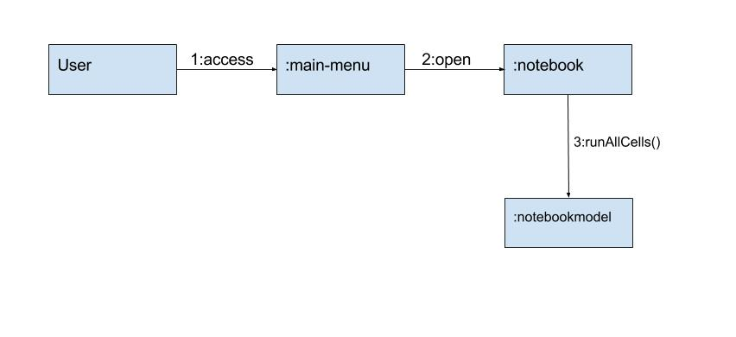

**Class Table**

|  |  |  |
| --- | --- | --- |
| **Class** | **Relation with Design** | **Related To** |
| beaker | Main class of the software | mainapp |
| mainapp | Does not exist in our design; we may not have considered it because it is simply a shell that houses all of the other components | beaker,  main-menu,  notebookmodel |
| notebookmodel | Matches Notebook in our OO design | mainapp,  cell,  textcell,  sectioncell,  newcellmenu |
| main-menu | Matches NavigationBar in our OO design | notebookmodel |
| cell | Matches Cell in our OO design | notebookmodel |
| textcell | Matches Textbox in our OO design | notebookmodel |
| sectioncell | Matches Section in our OO design | notebookmodel |
| newcellmenu | Matches ActionBar in our OO design | notebookmodel |
| file | Matches FileMenu in our OO design | main-menu,  publicationctrl,  file_filesys |
| debug | Does not exist in our design; we may not have considered it because the Debug menu was not used in our chosen use cases | main-menu |
| controlpanel | Does not exist in our design; we may not have considered it because the Control Panel menu was not used in our chosen use cases | main-menu |
| notebook | Matches NotebookMenu in our OO design | main-menu |
| view | Matches ViewMenu in our OO design | main-menu |
| help | Matches HelpMenu in our OO design | main-menu |
| publicationctrl | Matches PublishDialog in our OO design | file |
| file_filesys | This is a utility class that doesn't exist in our implementation because its utility may only have been felt when realizing class FileMenu | file |

**Reports**

**Classes Missing From Design**

beaker - “The root of everything”

mainapp - This is Beaker’s shell, holding active Notebooks and the Main Menu

debug - This is the Debug dropdown menu on the Main Menu

controlpanel - This is the Control Panel dropdown on the Main Menu

file_filesys - This adds file system specific menu items to the File Menu

**Extra Classes In Design**

LandingPage - Instead of being its own class, this is housed by mainapp

User - Beaker users are kept in TwoSigma space rather than Beaker space. We looked for any usage of a “user” class, possibly in a “user.rb” file, but nothing was found.

**Adjusted Classes**

FileMenu - Renamed to “file”

ViewMenu - Renamed to “view”

NotebookMenu - Renamed to “notebook”

HelpMenu - Renamed to “help”

PublishDialog - Renamed to “publicationctrl”

Notebook - Renamed to “notebookmodel”

NavigationBar - Renamed to “main-menu”

Section - Renamed to “sectioncell”

Textbox - Renamed to “textcell”

ActionBar - Renamed to “newcellmenu”

Cell - Renamed to “cell”

**Com S 362 — Object-Oriented Analysis and Design**

**Certification of Individual Contribution and Understanding Form**

Project Name: Design to Code Traceability Team Facilitator: Christian Klein

Homework Set: Studio #9 Date: 10-31-2016

Directions: Enter each team member’s name, and a “work rating” (1 - 5 with 5 as high and 1 as low score) that corresponds to the relative share of work done by the team member. Comments to explain work ratings other than 3 must also be provided. The total of the ratings must add up to 3 times the number of team members. Each team member must sign at the end of the form showing your agreement to your team member’s contribution.

*The work rating will have a direct and significant effect on each student’s project and ultimately course grade. In fairness to all students, each team member must give this rating their attention.*

Also, each team member should individually rate the percentage that they understand of the solution. (This does not affect the grade, but is used as a means of communication.)

|  |  |  |  |
| --- | --- | --- | --- |
| Printed team member’s name | Work  Rating  (1 - 5) | Comments/Explanations | Understanding  Self Rating  (0 to 100%) |
| Christian Klein | 3 |  | 90% |
| Derek Yu | 3 |  | 90% |
| Jay Patel | 3 |  | 90% |
| Joe Thill | 3 |  | 90% |
| Zifeng Jiang | 3 |  | 90% |
| Total: | 15 |  | |

Note that you must make Total = 3 * (Number of team members)

|  |
| --- |
| I agree to the above ratings and understand our team’s solution. |
| Christian Klein |
| Derek Yu |
| Jay Patel |
| Joe Thill |
| Zifeng Jiang |